Exercise 3: Creating Functional Components and Applying Styles in React
Aim
To create React functional components, apply CSS styling to components, and render them in a React application.

Theory Questions and Answers
1. Explain React Components.
React Components are independent and reusable blocks of code that return JSX elements to be displayed on the user interface.
Features:
- Reusable
- Modular
- Easy to maintain
- Improves code organization

2. Difference Between React Components and JavaScript Functions
React Components | JavaScript Functions
Return JSX elements | Return values
Used to create UI | Used to perform tasks
Can manage state using Hooks | Cannot manage React state directly
Rendered by React | Executed by JavaScript
Component names start with uppercase letters | Function names can be any valid identifier

3. Types of Components in React
Functional Components
- JavaScript functions that return JSX.
- Simpler and easier to write.
- Support Hooks.
Example:
function Home() {
return <h1>Home Component</h1>;
}
Class Components
- ES6 classes extending React.Component.
- Use render() method.
- Can maintain state.
Example:
class Home extends React.Component {
render() {
return <h1>Home Component</h1>;
}
}

4. Explain Class Component
A Class Component is a JavaScript class that extends React.Component and contains a render() method.
Syntax
class Student extends React.Component {
render() {
return (
<h1>Student Component</h1>
);
}
}
Advantages
- Supports state management
- Supports lifecycle methods
- Suitable for large applications

5. Explain Functional Component
A Functional Component is a JavaScript function that returns JSX.
Syntax
function Student() {
return (
<h1>Student Component</h1>
);
}
Advantages
- Less code
- Easy to understand
- Better performance
- Supports React Hooks

6. Define Component Constructor
A Constructor is a special method in a class component used to initialize state and bind methods.

Syntax
constructor(props) {
super(props);
this.state = {
name: "Aastha"
};
}
Uses
- Initialize state
- Bind event handlers
- Execute setup code

7. Define render() Function
The render() method is used in class components to return JSX that will be displayed in the browser.
Syntax
render() {
return (
<h1>Hello React</h1>
);
}
Purpose
- Generates UI
- Returns JSX elements
- Updates view when state changes

Procedure
Step 1: Create React Application
npx create-react-app scorecalculatorapp

Step 2: Move to Project Folder
cd scorecalculatorapp

Step 3: Create Functional Component
Create a file named:
src/Components/CalculateScore.js
Add the following code:
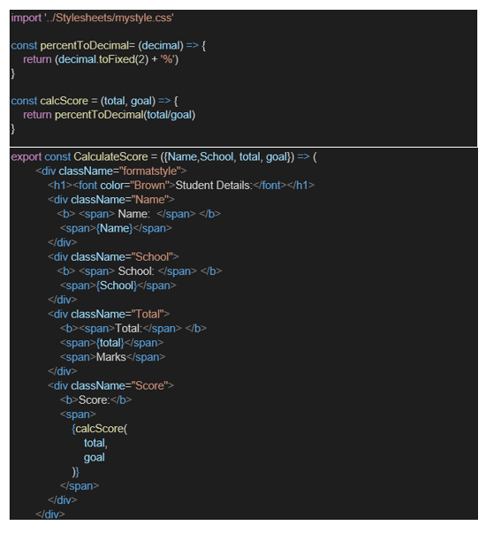
Step 4: Create CSS File
Create a Folder named Stylesheets and add a file named “mystyle.css” in order to add some styles to the components:
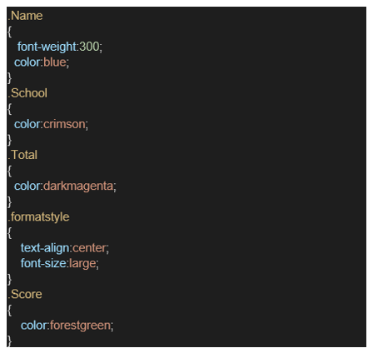

Step 5: Edit the App.js to invoke the CalculateScore functional component as follows:
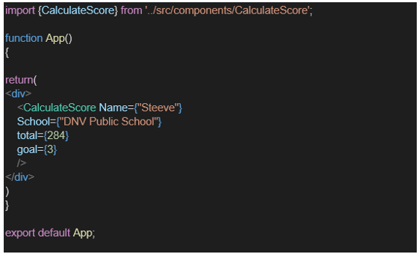
Step 6: Run Application
C:\scorecalculatorapp>npm start

Step 7: Open Browser
http://localhost:3000

Output
The browser displays:


Result
The React application was successfully created. A functional component was developed, CSS styling was applied, and the component was rendered successfully in the browser.

